

CENTRE FOR EXCELLENCE IN DESIGN FOR ALL - CEDA
Výskumné a školiace centrum bezbariérového navrhovania

Faculty of Architecture, Slovak University of Technology, Bratislava Tel.: 02 / 5727 6419, Fax: 02 / 5296 8747

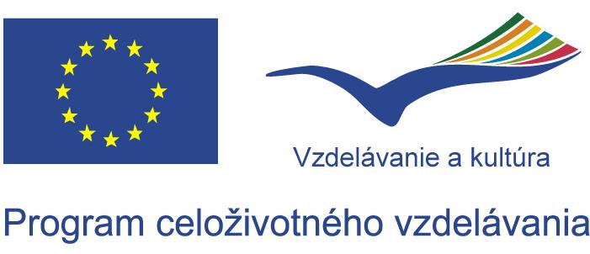
INTERNATIONAL WORKSHOP
IP ERASMUS „Tourism for All“
Bratislava, Poprad 4 May – 17 May 2008

Lectures Programme – BRATISLAVA

Monday 5 May

Meeting Room no. 117 (1st Floor left side), Faculty of Architecture, Nam. Slobody 19

10:00 - 12:00 Opening session
- Welcome speach
- Maria Samova, Project Coordinator, Faculty of Architecture, STU in Bratislava
- Lubica Vitkova, Vice-Dean of Faculty of Architecture, STU in Bratislava
- Gabriel Kuliffay, Director of Tourism Section, Ministry of Economy of the Slovak Republic
- Design for All in Theory and Practice applied to Tourism
Pete Kercher, EIDD - Design for All Europe

12:00 - 13:00 Lunch
13:20 - 13:50 Pedagogical and logistic model of the IP

14:00 - 16:30 Lectures
- Principles of Universal Design in Various Built Environments and their Mutual Conditioning
Maria Samova, Faculty of Architecture, STU in Bratislava
- Universal Design Education Project and Tourism for All in Belgium
Yvonne Knevels, Department of Architecture, PHL Limburg
- Barrier-free Buildings for Tourism - Design Principles
Monika Anna Klenovec, Faculty of Architecture, TU Vienna

Tuesday 6 May
Meeting Room no. 117 (1st Floor left side), Faculty of Architecture, Nam. Slobody 19

9:30 - 12:00 Lectures

- Cities without barriers
Marek Wysocki, Faculty of Architecture, GUT in Gdansk
- Prague for All
Irena Sestakova, Faculty of Architecture, CVUT Prague
- Design for All in Germany
Cornelia Otto, Faculty of Architecture, TU Dresden

12:00 - 13:00 Lunch

13:30 - 16:00 Lectures

- Leisure Facilities without Barriers
Lea Rollova, Faculty of Architecture, STU in Bratislava
- Accessible Historical Buildings
Zuzana Ceresnova, Faculty of Architecture, STU in Bratislava
- Barrier-free Design of Selected Types of Transport Buildings: Terminals of Railway and Bus Transport
Pavol Korcek, Faculty of Architecture, STU in Bratislava

Wednesday 7 May
Departure to Poprad

At the workshop in Poprad the students under the professor’s supervision will work on the specific task concerning “Tourism for All”.

